Trace Stewart

CPE301 – SPRING 2018

Design Assignment 4

**DO NOT REMOVE THIS PAGE DURING SUBMISSION:**

The student understands that all required components should be submitted in complete for grading of this assignment.

|  |  |  |  |
| --- | --- | --- | --- |
| **NO** | **SUBMISSION ITEM** | **COMPLETED (Y/N)** | **MARKS**  **(/MAX)** |
| 1 | COMPONENTS LIST AND CONNECTION BLOCK DIAGRAM w/ PINS |  |  |
| 2. | INITIAL CODE OF TASK 1/A |  |  |
| 3. | INCREMENTAL / DIFFERENTIAL CODE OF TASK 2/B |  |  |
| 3. | INCREMENTAL / DIFFERENTIAL CODE OF TASK 3/C |  |  |
| 3. | INCREMENTAL / DIFFERENTIAL CODE OF TASK 4/D |  |  |
| 3. | INCREMENTAL / DIFFERENTIAL CODE OF TASK 5/E |  |  |
| 4. | SCHEMATICS |  |  |
| 5. | SCREENSHOTS OF EACH TASK OUTPUT |  |  |
| 5. | SCREENSHOT OF EACH DEMO |  |  |
| 6. | VIDEO LINKS OF EACH DEMO |  |  |
| 7. | GOOGLECODE LINK OF THE DA |  |  |
|  |  |  |  |
|  |  |  |  |

1. **COMPONENTS LIST AND CONNECTION BLOCK DIAGRAM w/ PINS**

The components used in this lab were 3 different motors: DC motor, Stepper Motor, and Servo Motor. The DC motor will be connected to the l293D chip and the Stepper motor will be connected to the ULN2003 chip.

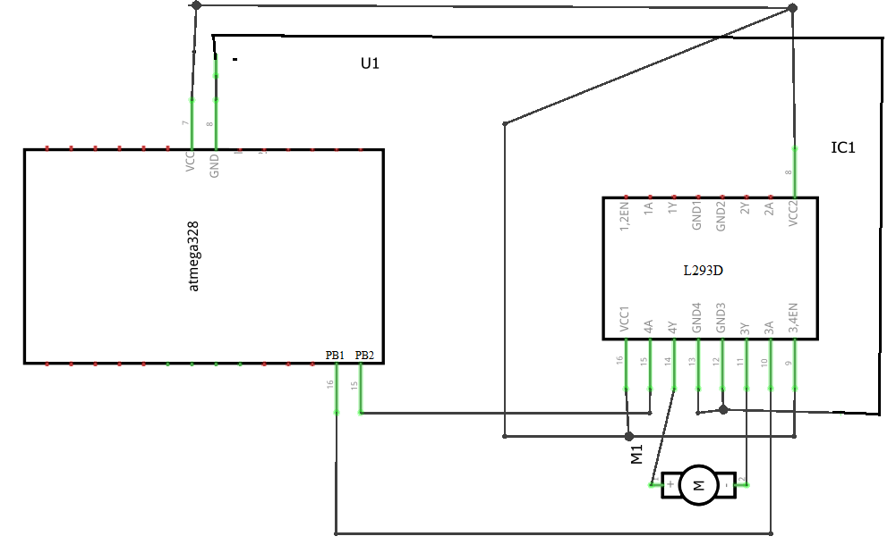

Figure : DC Motor

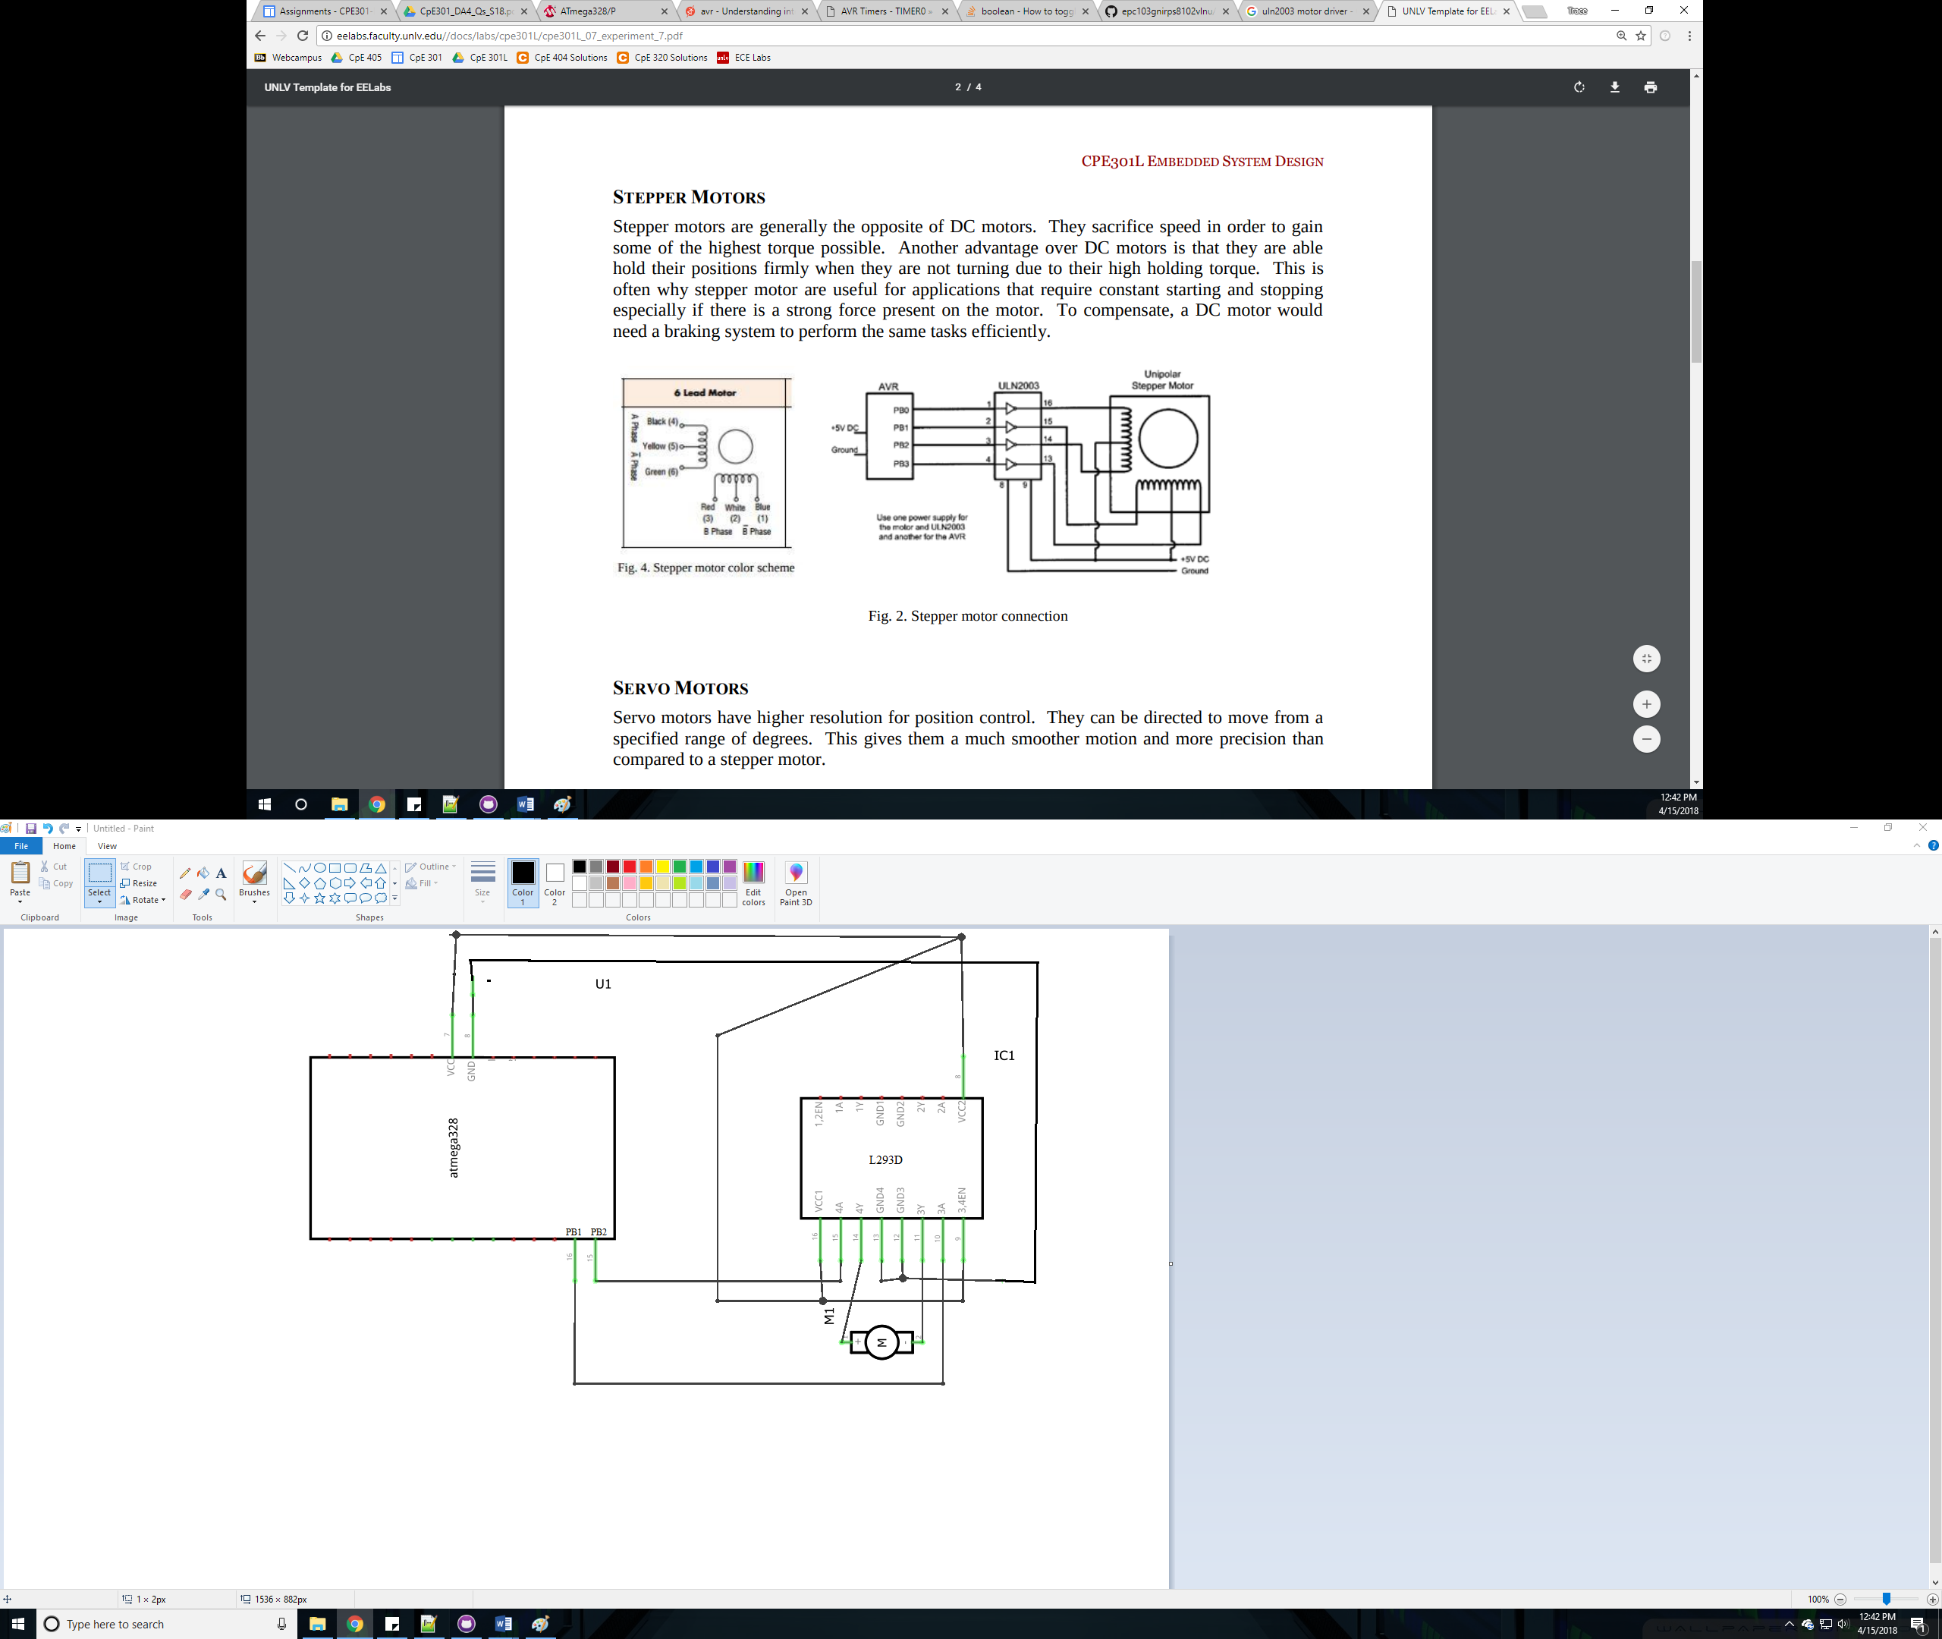

Figure : Stepper Motor

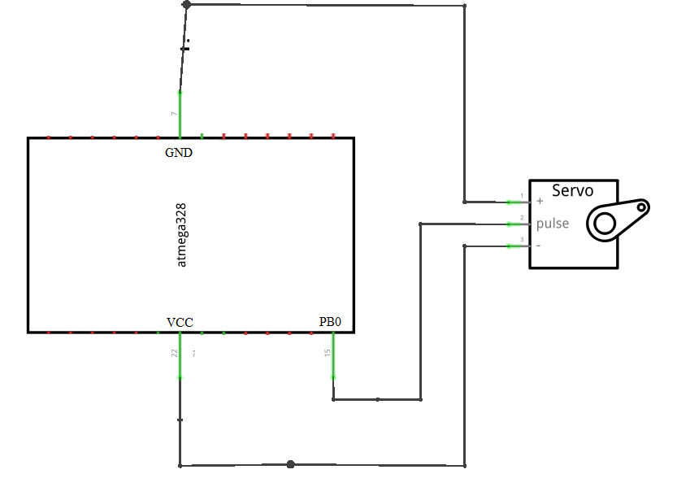

Figure : Servo Motor

1. **CODE OF TASK 1**

/*

* DC Motor.c

*

* Created: 3/23/2018 7:28:10 AM

* Author : trace

*/

#include <avr/io.h>

#define F_CPU 8000000UL

#include <util/delay.h>

#include <avr/interrupt.h>

// Variable Declaration

volatile unsigned int adcVal; // holds value of ADC

volatile unsigned int pressed;

int main(void){

// port initialization

DDRB = (1<<1)|(1<<2); // PB.1-2 (OC1A & OC1B) as output to generate PWM

DDRC = 0; // PORTC as input

DDRD |= 0xFF; //PD2 Input

//PORTD |= (1 << 2);

// timer 1 initialization - generate 50Hz PWM

TCCR1A |= (1<<COM1A1)|(1<<COM1B1)|(1<<WGM11); // enable PWM for OC1A & OC1B

// Fast PWM, Non-inverted mode

TCCR1B |= (1<<WGM13)|(1<<WGM12)|(1<<CS10); // 8 prescaling

ICR1 = 65535; // top value for timer1

OCR0A = 122; //OCR0A is set compare register to 128

TCCR0B=(1 << CS02) | (1 << CS00); //TCCR0B sets prescaler to None

TCCR0A=0x83; //TCCR0A sets WGM00 and WGM01 to 1 which sets Fast PWM as well as COM0A1 and COM0B1 to 1 which clears OCR0A when compare match.

TIMSK0 |= (1 << TOIE0);

// initialize ADC

DDRC = 0; // Set PORTC as input for adc

DIDR0 = 0x1; // Disable digital input on ADC0 pin

ADMUX = 0; // ADC0 (PC.0) used as analog input

ADMUX |= (1 << REFS0); // use AVcc as the reference

ADMUX |= (1 << ADLAR); // Right adjust for 8 bit resolution

ADCSRA = 0x87; // Enable ADC, system clock, 10000111

ADCSRB = 0x0; // Free running mode

EIMSK = 1<<INT0; // Enable INT0

EICRA = 1<<ISC01 | 1<<ISC00; // Trigger INT0 on rising edge

sei();

while (1){

ADCSRA |= (1 << ADSC); // start conversion

while((ADCSRA&(1<<ADIF))==0); // wait for conversion to finish

adcVal = ADCH; // extract right 10-bits of ADC register

if(pressed) {

OCR1A = 257*adcVal; // OCR1A value for duty cycle

}

if(!pressed) {

OCR1A = 0; // OCR1A value for duty cycle

}

}

return 0;

}

ISR(TIMER0_OVF_vect) {

if((PIND & (1<< PIND0))!=0){

pressed = !pressed;

}

}

1. **CODE OF TASK 2**

#include <avr/io.h>

#include <avr/interrupt.h>

#define F_CPU 8000000L

#include <util/delay.h>

#include <stdlib.h>

volatile int ovrflw; // global variable for keeping track of # of times Timer0 overflows

volatile uint8_t ADCvalue; // Global variable, set to volatile if used with ISR

int main(void)

{

DDRB = 0xFF;

// initialize ADC

DDRC = 0; // Set PORTC as input for adc

DIDR0 = 0x1; // Disable digital input on ADC0 pin

ADMUX = 0; // ADC0 (PC.0) used as analog input

ADMUX |= (1 << REFS0); // use AVcc as the reference

ADMUX |= (1 << ADLAR); // Right adjust for 8 bit resolution

ADCSRA = 0x87; // Enable ADC, system clock, 10000111

ADCSRB = 0x0; // Free running mode

// set up timer with prescaler = 64 and CTC mode

TCCR1B |= (1 << WGM12)|(1 << CS11)|(1 << CS10);

// initialize counter

TCNT1 = 0;

// initialize compare value

OCR1A = 0;

// enable compare interrupt

TIMSK1 |= (1 << OCIE1A);

while(1)

{

ADCSRA |= (1 << ADSC); // Start conversion

while((ADCSRA&(1<<ADIF))==0); // Wait for conversion to finish

if(ADCH < 245){

ADCvalue = ADCH + 10; // Only need to read the high value for 8 bit then equation for Fahrenheit

PORTB = 0x0C;

sei();

PORTB = 0x09;

sei();

PORTB = 0x03;

sei();

PORTB = 0x06;

sei();

}

}

}

ISR (TIMER1_COMPA_vect) {

for(int i=0;i<=ADCvalue;i++)

{

_delay_ms(1);

}

}

1. **CODE OF TASK 3**

/*

* Servo Motor.c

*

* Created: 3/23/2018 7:28:44 AM

* Author : trace

*/

#define F_CPU 8000000L

#include <avr/io.h>

#include <util/delay.h>

#include <avr/interrupt.h>

int main(void)

{

// initialize ADC

DDRC = 0; // Set PORTC as input for adc

DIDR0 = 0x1; // Disable digital input on ADC0 pin

ADMUX = 0; // ADC0 (PC.0) used as analog input

ADMUX |= (1 << REFS0); // use AVcc as the reference

ADMUX |= (1 << ADLAR); // Right adjust for 8 bit resolution

ADCSRA = 0x87; // Enable ADC, system clock, 10000111

ADCSRB = 0x0; // Free running mode

//Configure TIMER1

TCCR1A|=(1<<COM1A1)|(1<<COM1B1)|(1<<WGM11); //NON Inverted PWM

TCCR1B|=(1<<WGM13)|(1<<WGM12)|(1<<CS11)|(1<<CS10); //PRESCALER=64 MODE 14(FAST PWM)

ICR1=4999; //fPWM=50Hz (Period = 20ms Standard).

DDRB|=(1<<PB1); //PWM Pin as Out

while(1)

{

ADCSRA |= (1 << ADSC); // Start conversion

while((ADCSRA&(1<<ADIF))==0); // Wait for conversion to finish

//OCR1A=75; //90 degrees

//OCR1A=290; //0 degrees

OCR1A = (ADCH * 5 / 6) + 75;

}

}

1. **SCHEMATICS**

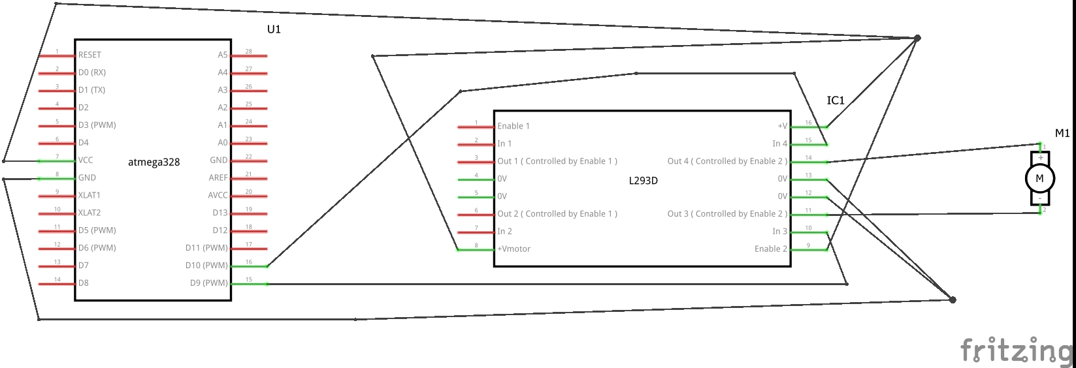

Figure :DC Motor

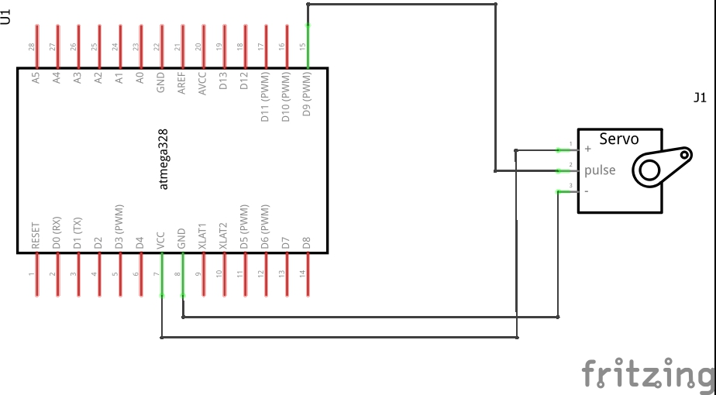

Figure :Servo Motor

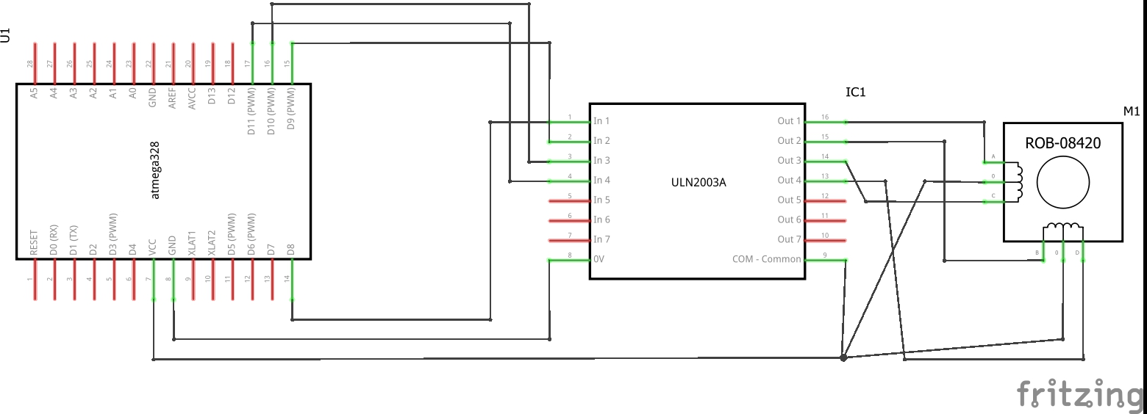

Figure : Stepper Motor

1. **SCREENSHOT OF EACH DEMO (BOARD SETUP)**

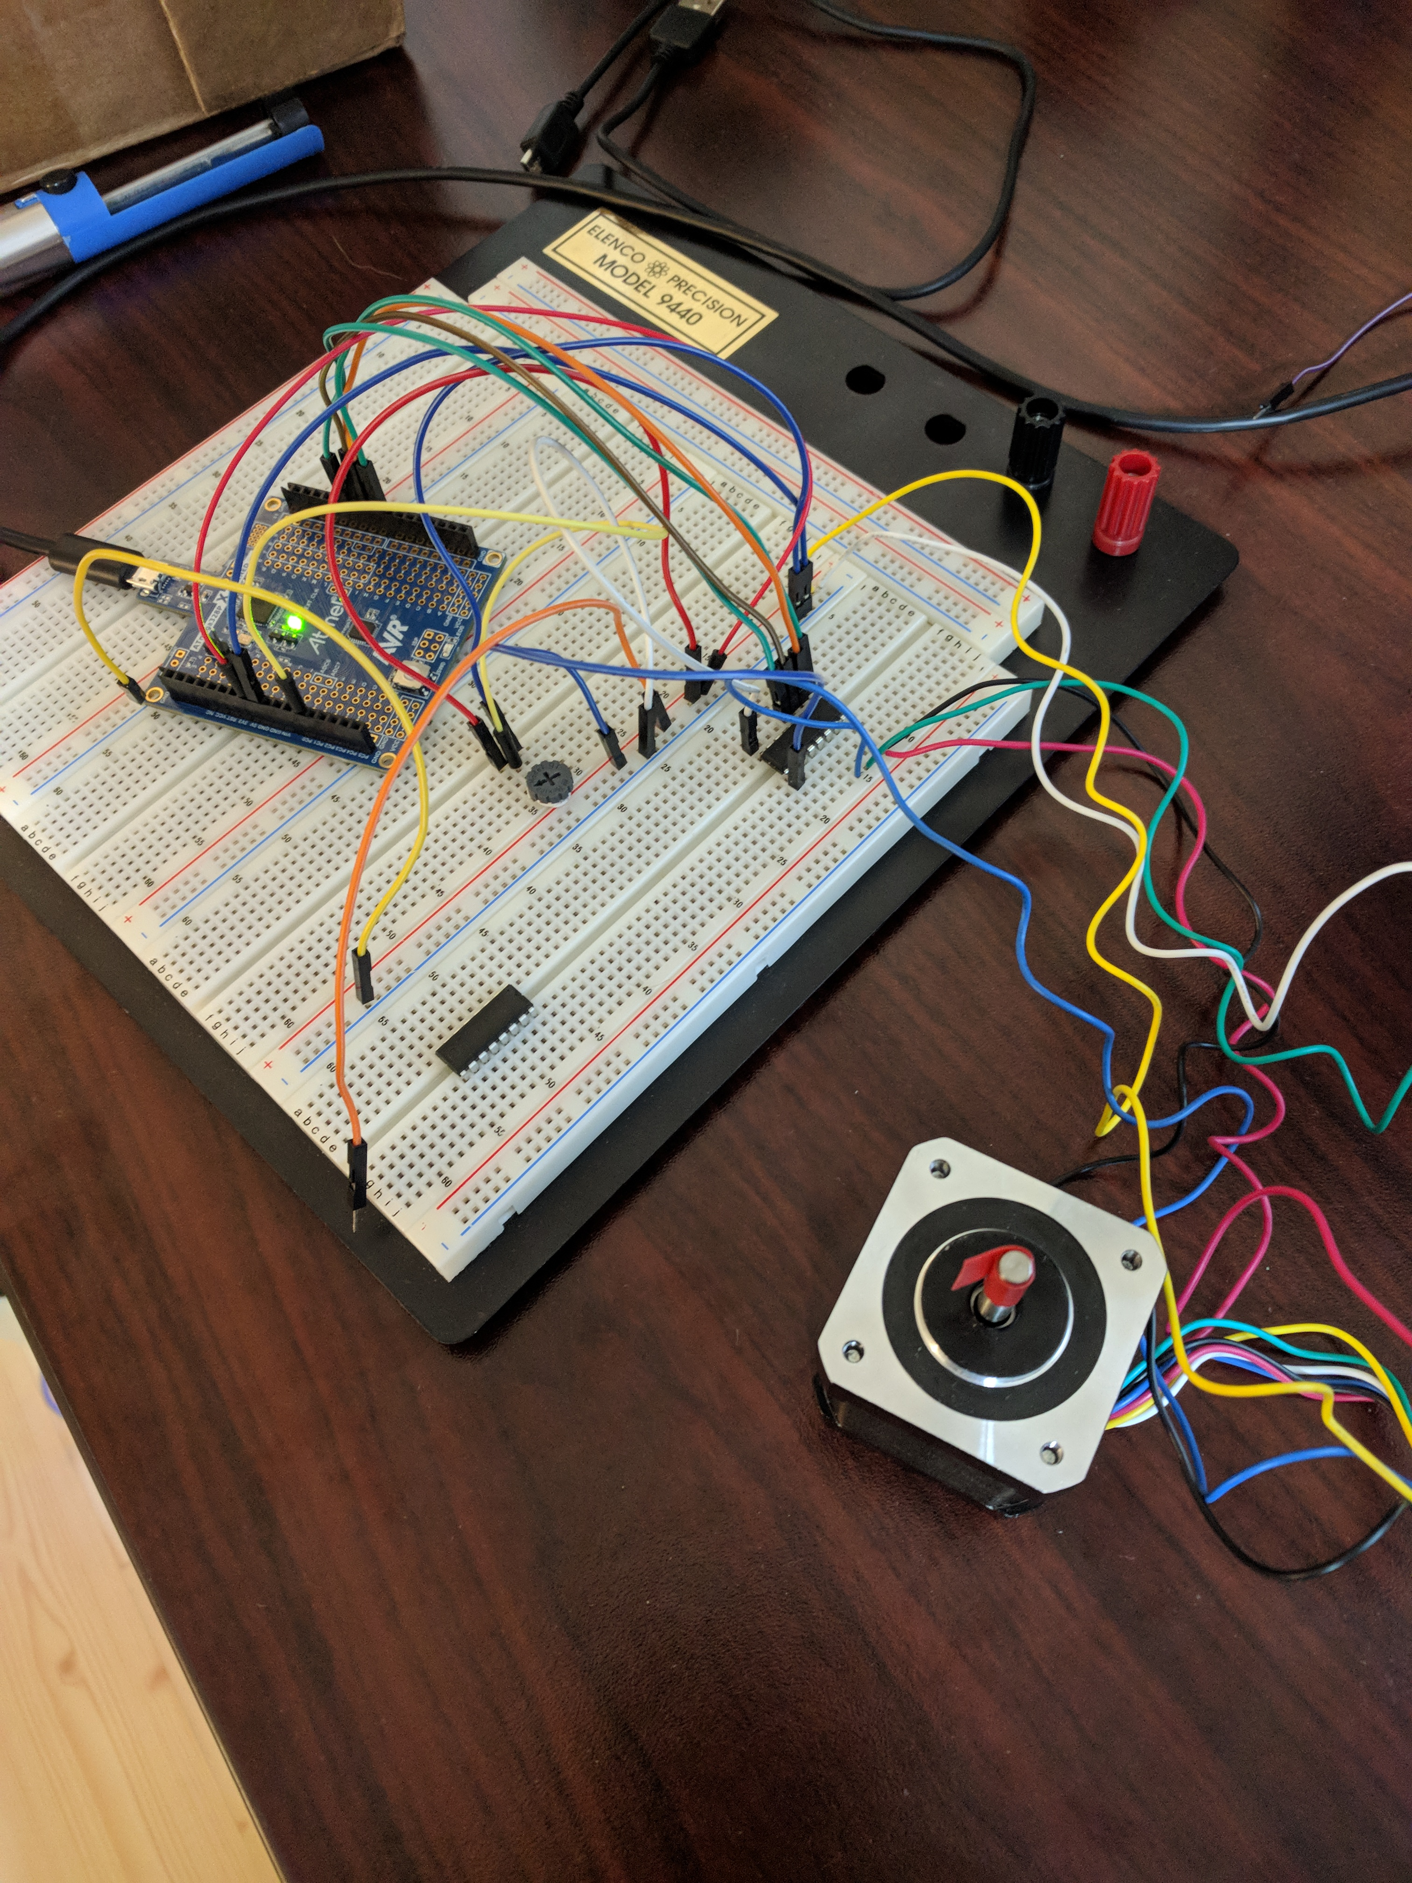

Figure :Stepper Motor

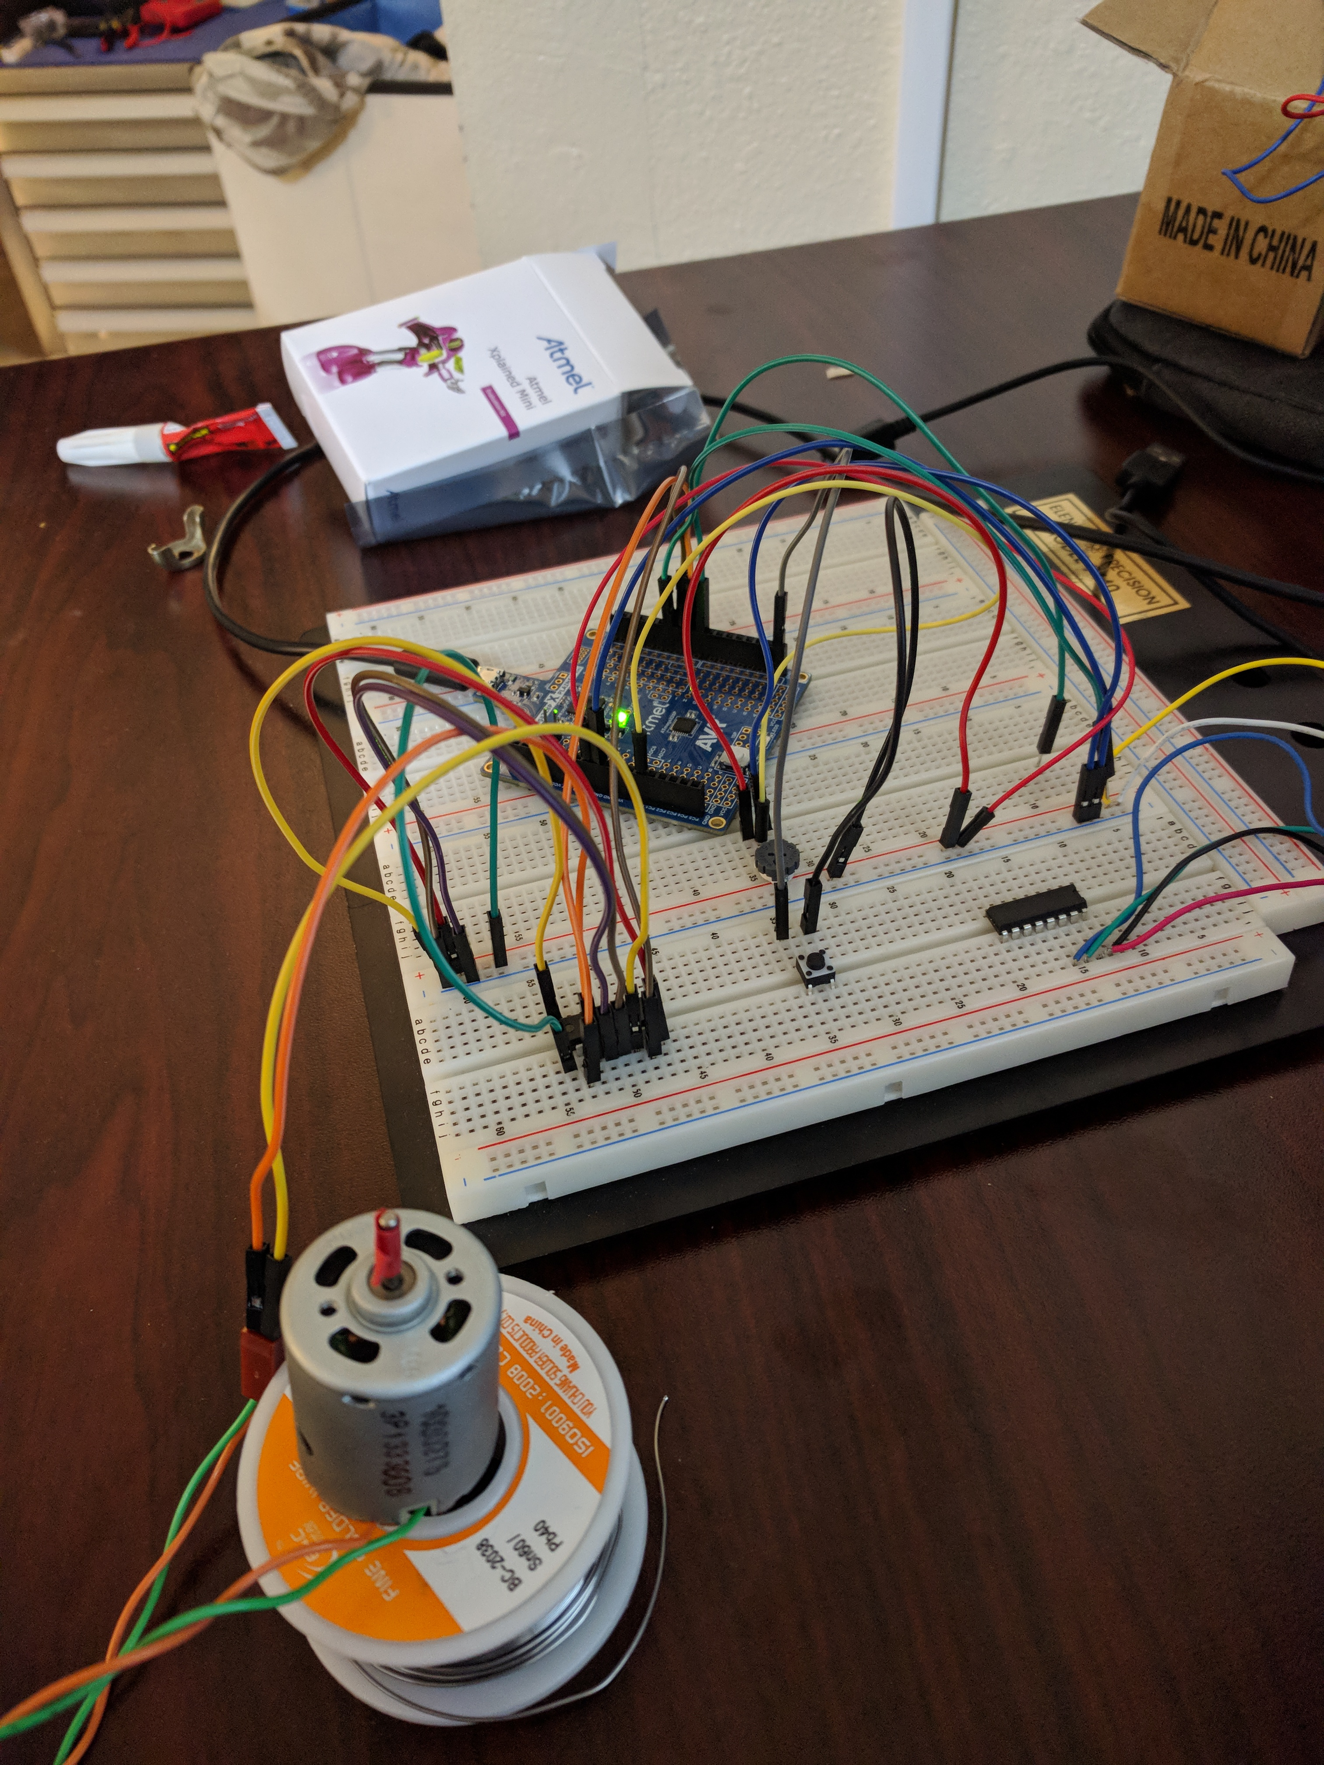

Figure : DC Motor

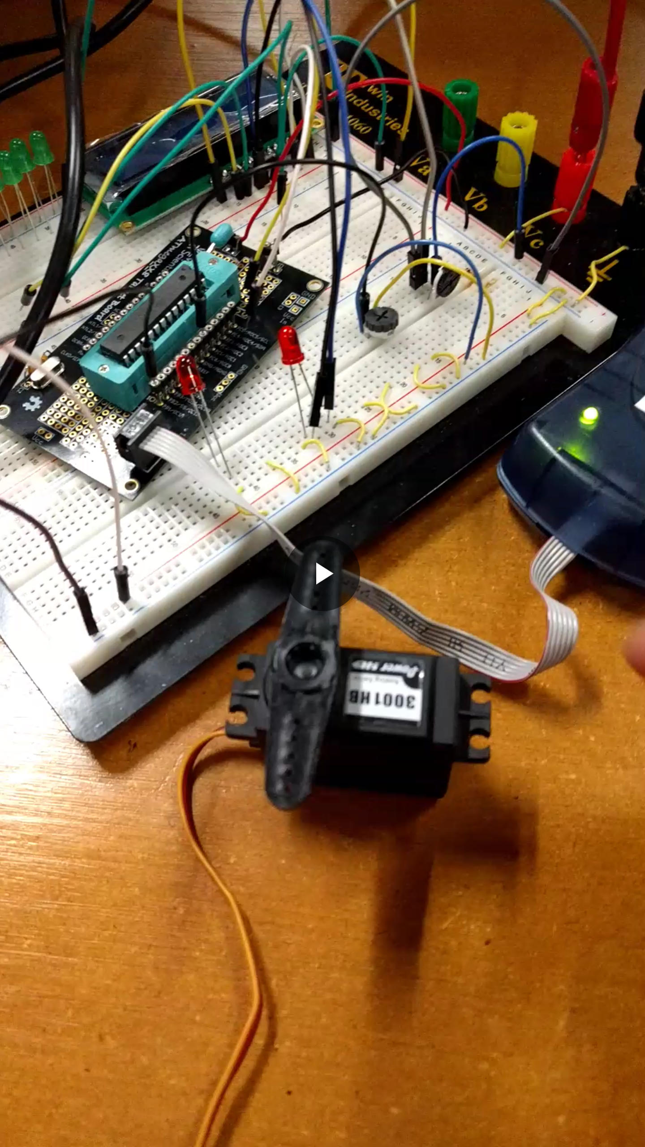

Figure : Servo Motor

1. **VIDEO LINKS OF EACH DEMO**

Task 1: https://www.youtube.com/watch?v=mORrXXEiRAg

Task 2: https://www.youtube.com/watch?v=3_fidSS8jNE

Task 3: https://www.youtube.com/watch?v=XMIAvHLSbeA

1. **GITHUB LINK OF THIS DA**

https://github.com/TraceStewart/epc103gnirps8102vlnu/tree/master/DA4

**Student Academic Misconduct Policy**

<http://studentconduct.unlv.edu/misconduct/policy.html>

“This assignment submission is my own, original work”.

Trace Stewart